Cloud Architecture Pattern

Azure API Gateway/Management

# Introduction

Azure API Management (APIM) is the component for managing and securing APIs in a services architecture. They provide a comprehensive solution for publishing, securing, transforming, and monitoring APIs, ensuring that your APIs are secure, scalable, and easy to manage.

# Context

* Azure API Management provides a platform for different stakeholders to produce and manage APIs.
* It abstracts the complexity of backend architecture, making it easier to expose services hosted on and outside of Azure.
* Ensures that APIs are secure and comply with organizational policies.
* Helps in scaling APIs to meet demand and optimize performance.
* Provides tools for monitoring API usage and performance, enabling data-driven decisions.

# Architecture

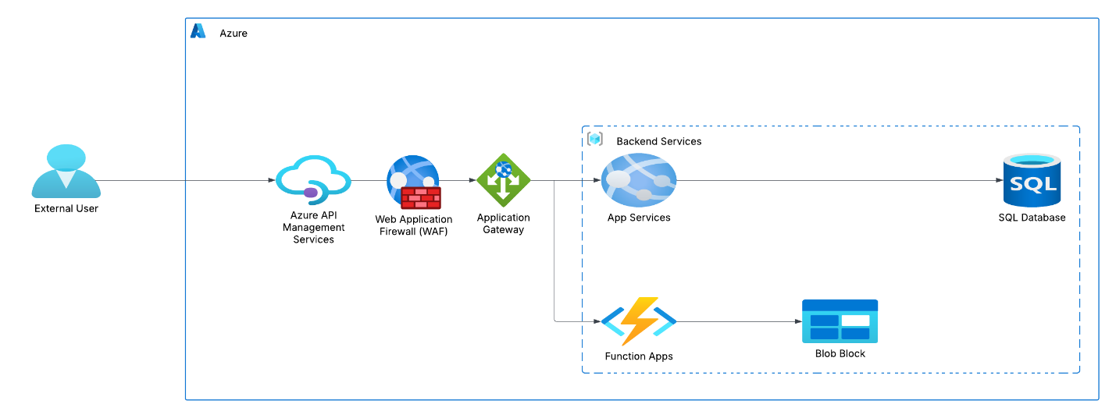

# Design Considerations

When designing an architecture that includes Azure API Management and Application Gateway, consider the following:

* **Security:  
  API Gateway:** Acts as a facade to backend services, handling API requests, applying policies, and collecting telemetry
* **Web Application Firewall (WAF)**: Protects your APIs from common threats and vulnerabilities
* **Authentication and Authorization:** Use API keys, JWT tokens, and certificates to verify credentials

**Scalability:**

* **Managed and Self-hosted Gateways:** Choose between managed gateways for simplicity or self-hosted gateways for hybrid and multi-cloud scenarios
* **Autoscaling:** Use Azure Monitor to auto scale API Management and Kubernetes horizontal pod auto scaler for self-hosted gateways

**Performance:**

* **Caching:** Configure response caching to improve latency and reduce load on backend services
* **Rate Limiting and Quotas:** Enforce usage quotas and rate limits to manage traffic and prevent abuse

**Monitoring and Logging:**

* **Telemetry:** Collect logs, metrics, and traces for monitoring, reporting, and troubleshooting
* **Application Insights:** Be aware of the performance impact of logging at high loads

**Routing and Traffic Management:**

* **URL-based Routing:** Route traffic based on URL patterns for flexible routing rules
* **Gateway Routing Pattern:** Use the gateway to restrict traffic source locations and ensure traffic quality